**Robotic Arm:**

We have run some experiment regarding the grabbing part of the robotic arm. The most available servo motor in Bangladesh is MG996R / MG995. Using this servo, it is quite difficult to grab the object from the ground using 6DOF arm. Though we bought 6 DOF arm but we modified the structure of the arm so that it can grab the objects so frequently.

**Arm Components (Modified):**

|  |  |  |  |
| --- | --- | --- | --- |
| **Item Name** | **Weight**  **(gm)** | **Length**  **(cm)** | **Image** |
| **1 x Metallic Claw** | **56** | **11** |  |
| **3 x Long U Shaped Bracket** | **22** | **6.4** |  |
| **3 x Multifunctional Bracket** | **16** | **5.6** |  |
| **1 x Cup Bearing** | **-** | **-** |  |
| **Item Name** | **Weight**  **(gm)** | **Length**  **(cm)** | **Image** |
| **2 x Hard U Beam** | **50** | **9** |  |
| **L-Bracket** | **6** | **-** |  |
| **7 x MG996R Servo** | **55** | **~4** |  |

**­­**

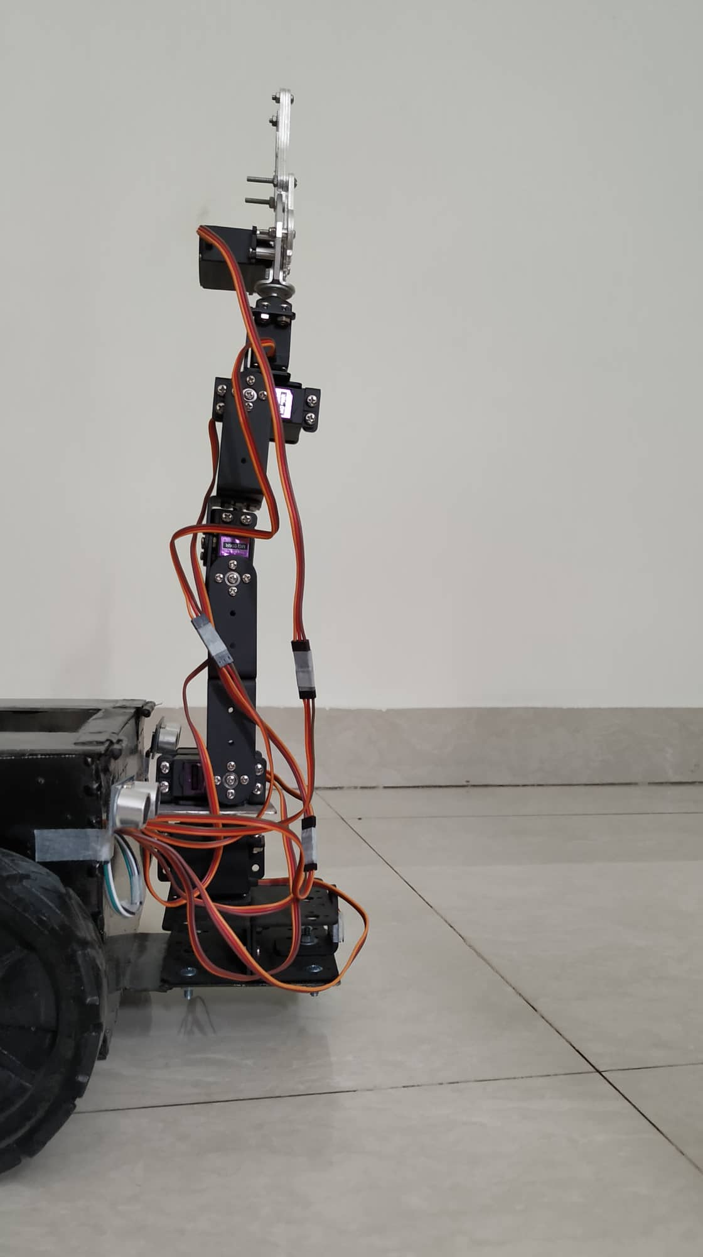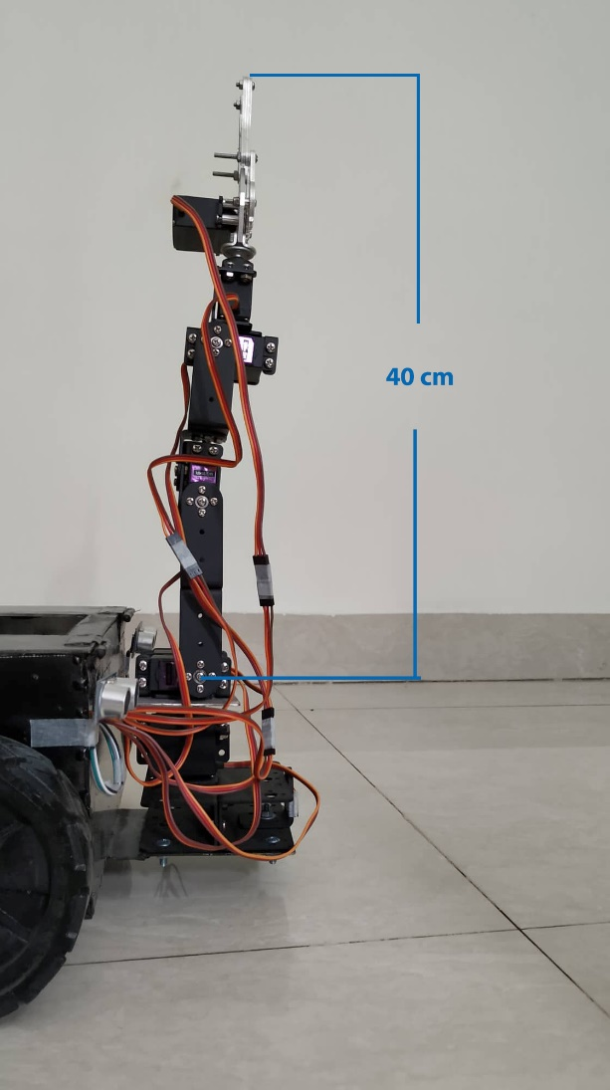

**Fig 1.1: Robotic Arm (modified) Fig 1.2: Robotic Arm (with required length)**

**Calculation:**

Torque of MG996R: **9.4 kg-cm** (at 4.8 v) [1]

Torque of MG996R: **11 kg-cm** (at 6 v) [1]

Operating Voltage: 4.8 v ~ 6.6 v [1]

We are operating at 6 v using 6v 4.5Ah battery. So, we are getting the maximum torque of 11kg-cm. [1]

**Torque Equation:**

http://www.softschools.com/formulas/images/torque_formula_4.png

The length from Shoulder (Servo2) to the gripper top is: ~40 cm

Maximum weight 1 MG996R servo can lift: 11 kg-cm / 40 cm = 275 gm

So, Total weight shoulder servos can lift: 275 x 2 gm = 550 gm

Equipment’s total weight above Servo2 : Weight of Claw + Weight of U Bracket x 3 + MG996R servo x 4 + Multifunctional Bracket x 3 + L-type Bracket x1

= (56 + 22 x 3 + 55 x 4 + 16 x 3 + 6) gm

= 396 gm, which is greater than 275 gm but less than 550gm

So, Shoulder servos can lift total weight of garbage = (550 – 396) gm = 104 gm which is enough for our project.

**Modification Necessity:**

If we used 1 servo in shoulder of the 6 DOF then the height from shoulder to the gripper top would be still approximately 40 cm.

Then it can lift maximum weight of = 11 kg-cm / 40 cm =0.275 kg ~ 275 gm

But component’s total weight above Shoulder would be = (56 + 22 x 3 + 55 x 4 + 16 x 3 + 6) gm

= 396 gm which is greater than 275 gm

So, it will not work properly.

**Note:** **In fact, we ran some tests earlier on 6DOF and we saw that Shoulder servo fall down with the excessive weight as it’s torque is not compatible with that much weight.**

So, we modified and used two servos together in the shoulder with the help of a customized metallic plate. After modifying our hand can grab the garbage and lift if properly. As our robotic hand is compatible with XYZ (3D) rotation so it is enough for our project.

**Power Consumptions:**

We have used 7 servos for robotic hand, 1 servo to rotate the basket, 1 for rotating camera. So in total 9 servos are used.

Each servo has a stall current of 1.4 A.

So total Stall current: (9 x 1.4) A = 12.6 A

We are using 6v 4.5Ah for powering up robotic hand servos along with basket servo and camera servo.

So the uptime of robotic hand and basket and camera rotation function is: (4.5/12.6) hr = 0.38 hr ~ 22 mins.

This is the uptime with full load functionalities. All the servos will not work at full load capacity because of their position. Neither all the servos are at the maximum distance from the gripper of the robotic hand nor they lift the maximum weight while picking garbage. So power(current) consumption is not equal for all the servos. We noticed that the actual uptime is almost triple of this time which is more than enough for our project.

The idle current draw for each servo: 10mA which is so low so we can ignore it.

Reference:

1. <http://www.towerpro.com.tw/product/mg996r/>